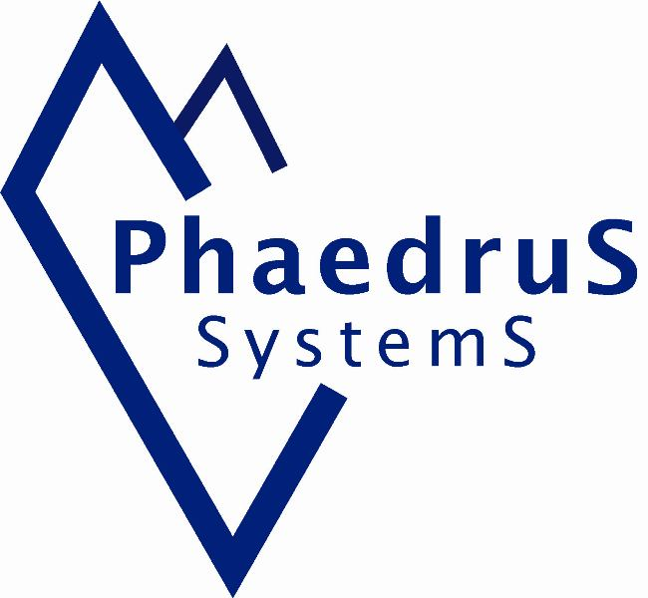
Phaedrus Systems: Background

Overview
Phaedrus Systems supports engineers at all stages of embedded safety-critical and high-integrity projects. Tools available include requirements capture for IEC 61508, EN 50128 and nuclear applications, a SIL3 RTOS, compiler validation reports and embedded database technology. Consultants have experience working on automotive, rail and aerospace applications, meeting standards such as IEC 61508 SIL4, and D0178B. Backing these is a wide range of other relevant embedded tools, including code checkers, USB and TCP/IP stacks, development kits, debuggers and ICE.
Independent advice is strengthened by the company’s founder being an active participant in several standards bodies, including ISO C, C++ and IEC 61508-3, a principal author of MISRA-C:2004 and member of the MISRA-C:2012 team.
Skill Set
Phaedrus Systems has both hardware and software skills. Real world hardware experience covers both the analogue and digital domains. Software skills include development in various languages on various systems, ranging from large Unix-based comms projects to smart cards. Staff have experience in leading technical teams and projects. This was gained from working on military systems (both air and ground based) at the sharp end and in development, working on experimental systems in safety critical industrial control, providing maintenance and even carrying out reverse engineering.
This means Phaedrus Systems can understand the development process from the different viewpoints of the development engineer, team or project leader and management, and can reconcile the different priorities. Having the right tools is only part of the solution - the process is also important.
We also understand the pressures on development teams, particularly the smaller ones, which is why we do not run the usual 9-5 service. In fact Phaedrus Systems has even provided technical support on a Sunday. We have been there: we are not going to take your money and run.
Engineering Disciplines
As a Chartered Engineer (also Eur Ing and an MIET and an MBCS) Chris firmly believes that whilst design is an art, every project should be underpinned by the engineering disciplines of technique, methods and process. Even artists will tell you that they have to learn techniques and methods and, although their work is not safety critical, they too often suffer with incomplete and changing customer specifications.
Phaedrus Systems and Standards
Chris Hills has been a member if the ISO/BSI C and C++ Language Panels since 1999 and was the convener of the UK C panel from 2000 to 2004. Chris also sat on the IEC 61508-3 Panel. Additionally, he has been part of MISRA-C since 1998 and been on the MISRA-C Technical Board since its inception. He is a member of the Technical Advisory Panel of the IET’s Microelectronics & Embedded Systems Network and a member of the IoT Security Foundation Plenary
Professionalism
If you are working on safety critical or high-integrity embedded systems, then Phaedrus Systems has the technical experience and professional skills to provide you with the right tools for the particular task. And in the unlikely event we do not have the appropriate tool in our carefully selected product range, then we will have no hesitation in guiding you to an alternative source.
Affiliations
Phaedrus Systems staff are individual Fellows or Members of:
The Institution of Engineering and Technology (IET),
The British Computer Society (BCS),
The Royal Society For the Encouragement of Arts, Commerce and Manufacture (RSA),
The Royal Geographical Society (RGS).
Contact
Contact Phaedrus Systems at:
www.phaedsys.com
info@phaedsys.com
Freephone: 0808 1800 358 (International +44 1827 259546)
Phaedrus Systems Limited,
96 Brambling, Tamworth, B77 5PG, United Kingdom
Appendix 1 – Principals and products
Ashware simulators: Ashware produces the essential simulators for the TPU, eTPU, CPU32 and CPU16.
Byte Craft compilers: Byte Craft has been producing a select range of highly optimised compilers and dev tools since 1976. They produce tools for the processors shown below. Byte Craft is, like Phaedrus Systems, heavily involved in the ISO- C panel Compilers for eTPU, PIC, 6808, 6805, Scenix, Z8 , C38, COP8 and Fuzzy Logic.
Cleanscape: Uniquely Phaedrus Systems can supply the Cleanscape GUI tool as a stand alone GUI for your current PC-Lint or supply it as a package with PC-Lint (PC or Unix/Linux versions available).
Code Warrior compilers: Phaedrus Systems staff have worked with both Hi-Ware and Metrowerks before they became CodeWarrior: the in house compiler company at Freescale. CodeWarrior produce compilers for the following targets: PowerPC, Coldfire, 68K, DSP, HC08, HCS12, and Star Core.
Cogent dev kits: Cogent Computer Systems designs, develops and manufactures a variety of Single Board Computers. The SBC's are based on some of the most advanced embedded architectures available today. Advanced Processors cores such as MIPS, XScale, ARM9/11, PowerPC and Coldfire.
Cosmic compilers: Cosmic Software has over 20 years experience in making C compilers and other embedded system development tools for a variety of microcontrollers from Freescale, STmicroelectronics and others.
Crossware compilers: Crossware Products develops and markets C/C++ compilers, assemblers, simulators and debuggers for embedded systems based upon the ARM, 8051, ColdFire, M68xxx and other chip families.
Dev kits: Phaedrus Systems can supply development kits from all the tools suppliers we distribute. We also supply various items of hardware from other suppliers and can obtain dev kits from many other places allowing us to "mix and match" to specific requirements.
Embednet IR stacks: IrPro SDK is a complete IrDA-Data infrared communications application software development kit (SDK) designed for embedded systems.
Galorath estimation tools: Galorath (SEER) has invested over two and a half decades of research and development helping organizations better plan and control project costs, quality, duration and risk. The tools leverage sophisticated model technology and project-applicable knowledge.
Gimpel PC-Lint and Flexe-Lint: PC-Lint and Flexe-lint are two of the oldest and most long lived static analysers in the world. Released in 1985 less than a decade after C first appeared it is the longest continuously advertised software tool in human history.
InHand dev kits: InHand has a range of XScale boards with Linux support.
Keil compilers: Keil started in 1986 with a C compiler for the 8051 family, the first built from the ground up. Since then Keil has expanded into the i86 and ARM families. Keil produces some of the best C compilers in their class. (C51, C16x, ARM, U-Link etc.)
McObject: McObject provides embedded database technology to meet the unique needs of intelligent, connected devices. eXtremeDB is a small-footprint in-memory database system (IMDS) optimized for use in set-top boxes, communications equipment and other embedded systems. McObject also provides Perst, an open source, object-oriented database for Java and .NET.
Programming Research: Established in 1986, Programming Research's extensive experience with leading global software development organizations enabled them to emerge as the industry's coding standard experts. PRQA is recognized worldwide as the leading authority in the assessment of software quality through automated source code analysis and development process improvements.
Pure-systems: Pure::variants provides variant management for systems with multiple options and versions of the software.
RiskCATS requirements capture: Safety critical standards, such as 61508, are large and complex. The RiskCAT requirements tools permit rapid and intuitive navigation around the standard(s). They provide a simple calculation of SIL and the selection of measures by key word, life cycle or function using or/and criteria. A simple click of the mouse pulls up the relevant part of the standard, with interfaces to DOORS and CalibreRM or Spreadsheet. Other tools include a stand-alone SIL calculator and static analysers for the executable in the ROM or flash.
Ristan code analysis and documentation generator: Development assistants will reverse engineer code producing flow charts, calling trees, cross-reference lists and documentation.
Sciopta RTOS: SCIOPTA Systems develops, sells, supports and maintains systems software for safety-critical embedded applications. Sciopta was founded over 20 years ago as Litronic AG. SCIOPTA is more than just an RTOS: it is a new and modern approach to design embedded systems.
Segger RTOS: SEGGER Microcontroller develops and distributes software development tools and ISO C software components (middle ware) for embedded systems in several industries such as telecom, medical technology, consumer electronics, automotive industry and industrial automation. Written entirely in ISO C, the tools can easily be used on most CPUs and any display.
Appendix 2: Company Name
Phaedrus Systems pronounced "fay-drus" Systems came about though chance - like many other thing in life. “Way back in 1979/80 I was in the RAF and we were trying out some CB radios.” says Chris Hills, founder and technical director. “We obviously needed some non-military call signs or "handles" in CB parlance. At the time I was reading Zen and the Art of Motorcycle Maintenance by Robert Pirsig. So I plucked the name of the main character, "Phaedrus" out of the book. The name, according to the book, at the time, meant "wolf" which as a young twenty-something military person sounded appealing."
Chris later used the name as a "company" name on ticket application forms to get into some trade shows and over time Phaedrus Systems found itself on various mailing lists (a bit like email addresses and spam now) and gained a life of its own. In 1992 www.phaedsys.demon.co.uk became the first "phaedsys" web site. It was used for embedded software engineering things and saw the start of the QuEST series of technical papers, BSI-C standards and MISRA-C work, the ESE columns and related topics. In 2000 Phaedrus Systems became a real company.
There is one more twist. By chance in 2006 the Marketing Director saw a 25th anniversary edition of Zen and the Art of Motorcycle Maintenance. In the additional material there was an admission that the author had made a mistake: Phaedrus did not mean "wolf" but "brilliant" or "radiant". It works just as well for a specialist engineering company.
June 2009

